Chapter 9: Straight line graphs
Skillsheet 9B: Finding gradients
Name: _____________________________
1 Decide if the gradients of these lines are positive, negative or zero.
a | 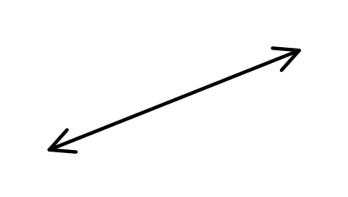 | b | 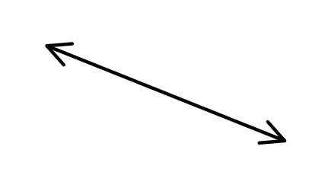 | c | 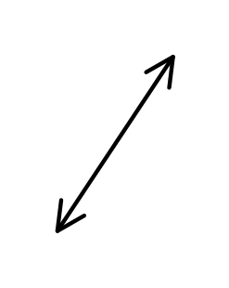
 | _________________ |  | _________________ |  | _________________
d | 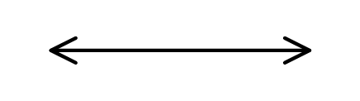 | e | 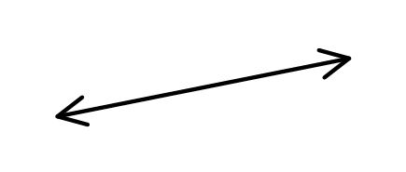 | f | 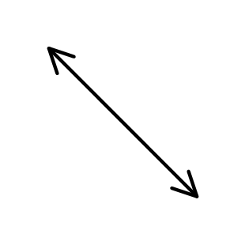
 | _________________ |  | _________________ |  | _________________

2 Write down the gradient, using 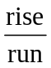 for each of these slopes.
a | 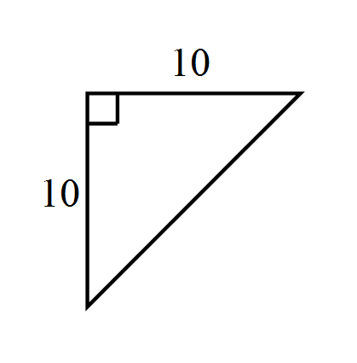 | b | 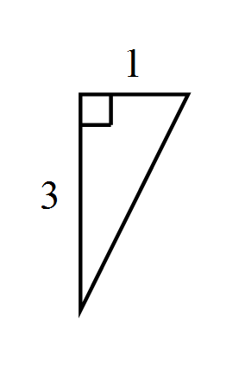 | c | 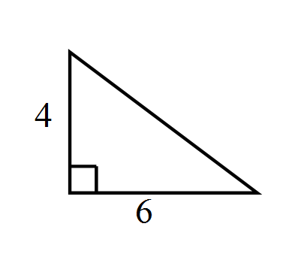 | d | 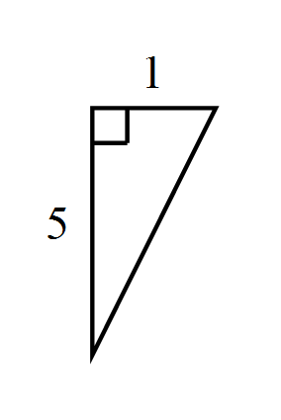
 | ____________ |  | ____________ |  | ____________ |  | ____________
e | 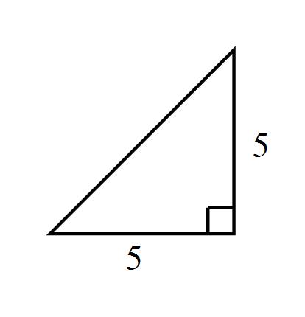 | f | 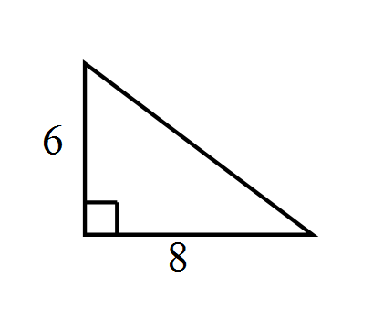 | g | 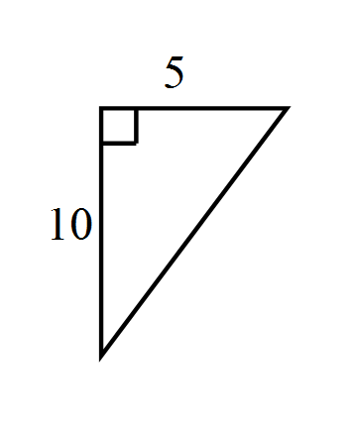 | h | 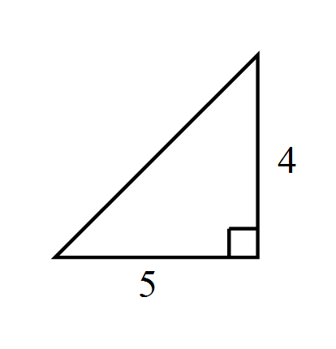
 | ____________ |  | ____________ |  | ____________ |  | ____________

3 Find the gradient of these lines.
a | 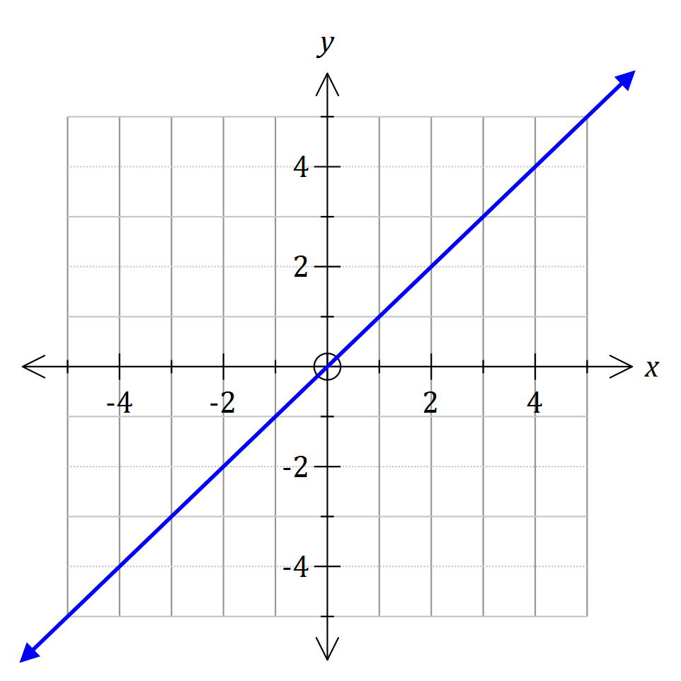 | b | 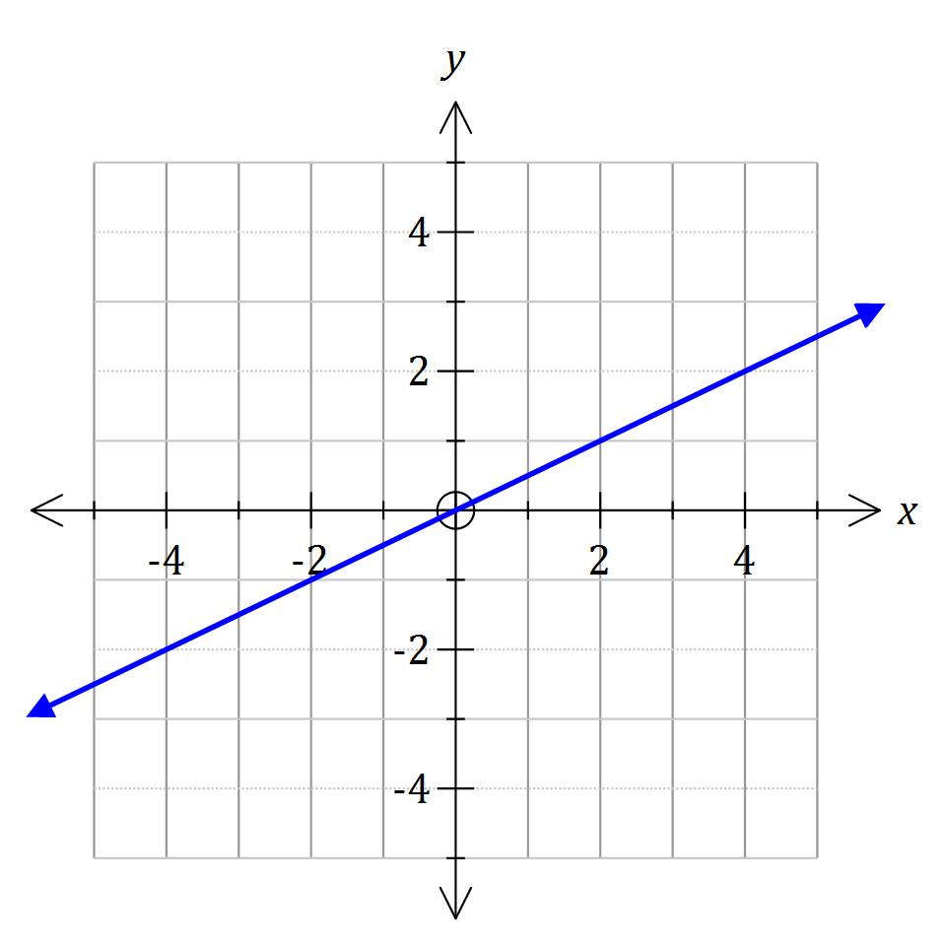 | c | 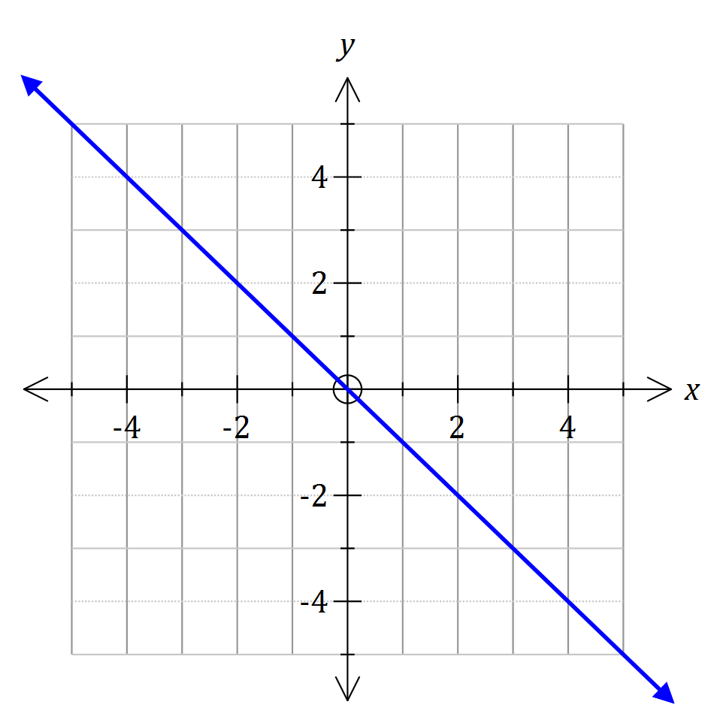
 | ________________ |  | ________________ |  | ________________
d | 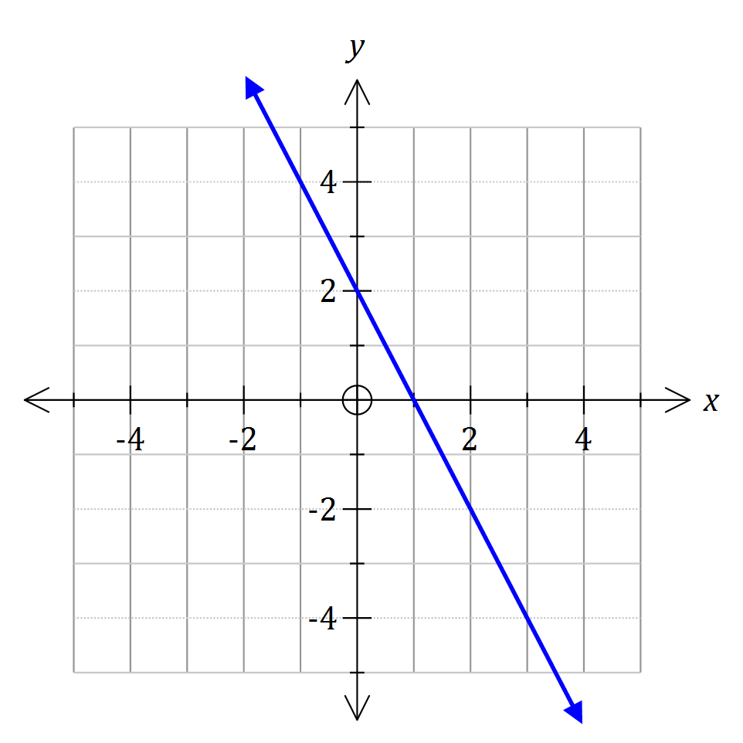 | e | 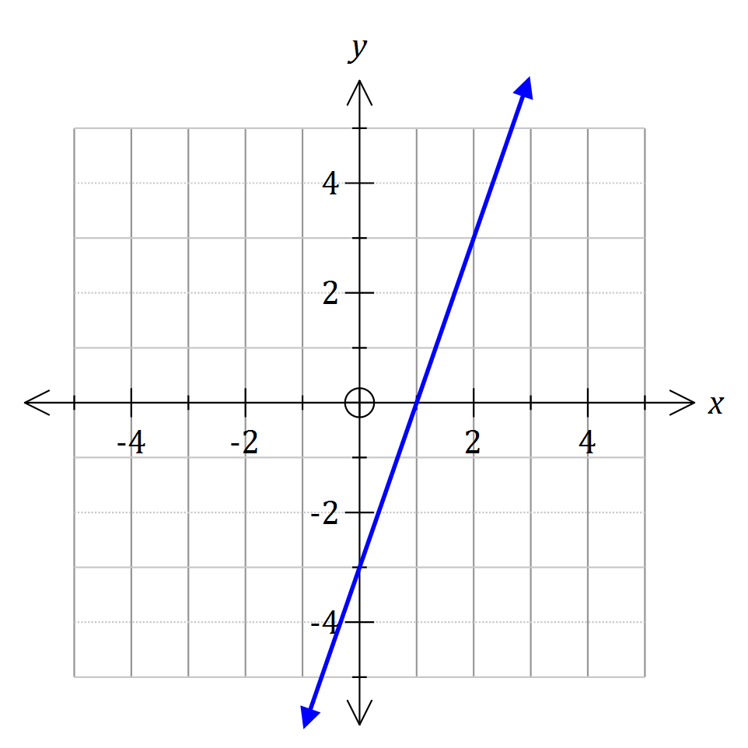 | f | 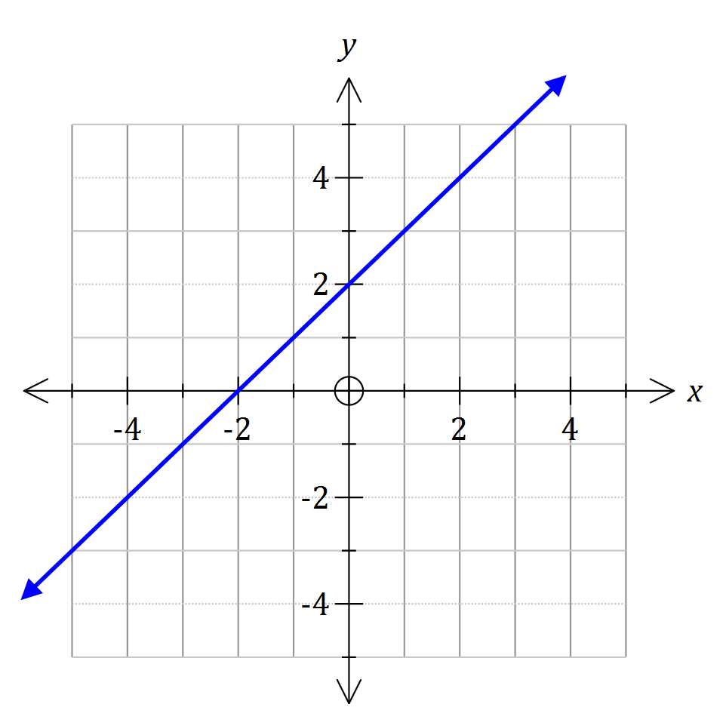
 | ________________ |  | ________________ |  | ________________
g | 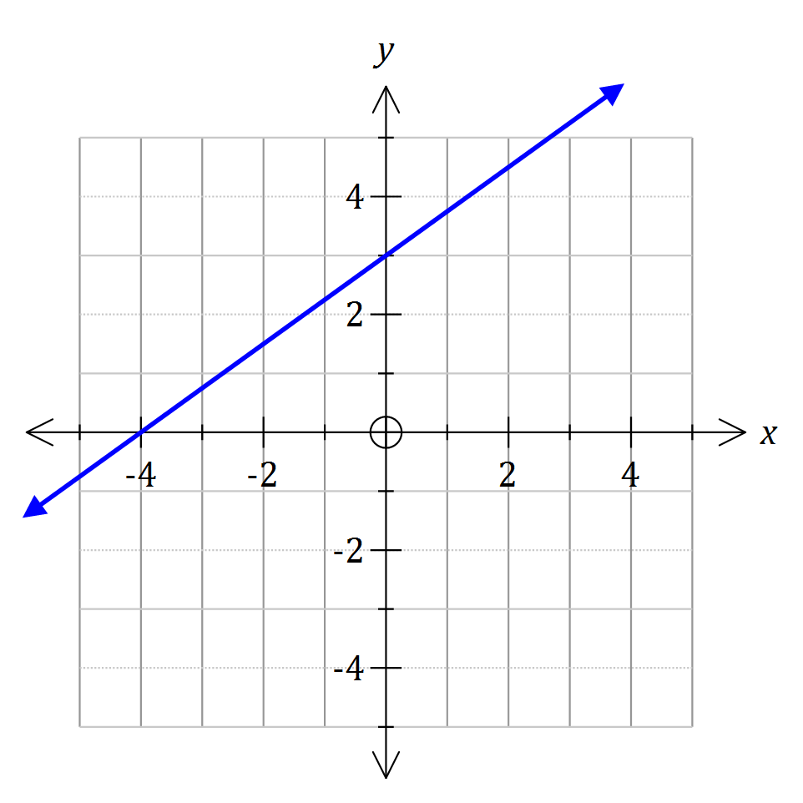 | h | 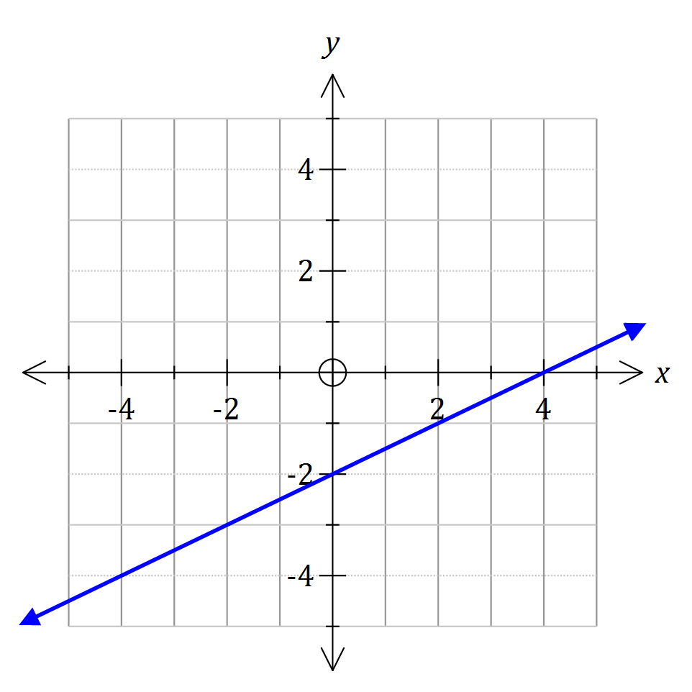 | i | 
          

